Total Hours spent: 40 minutes

3G MICROCELL

CISCO

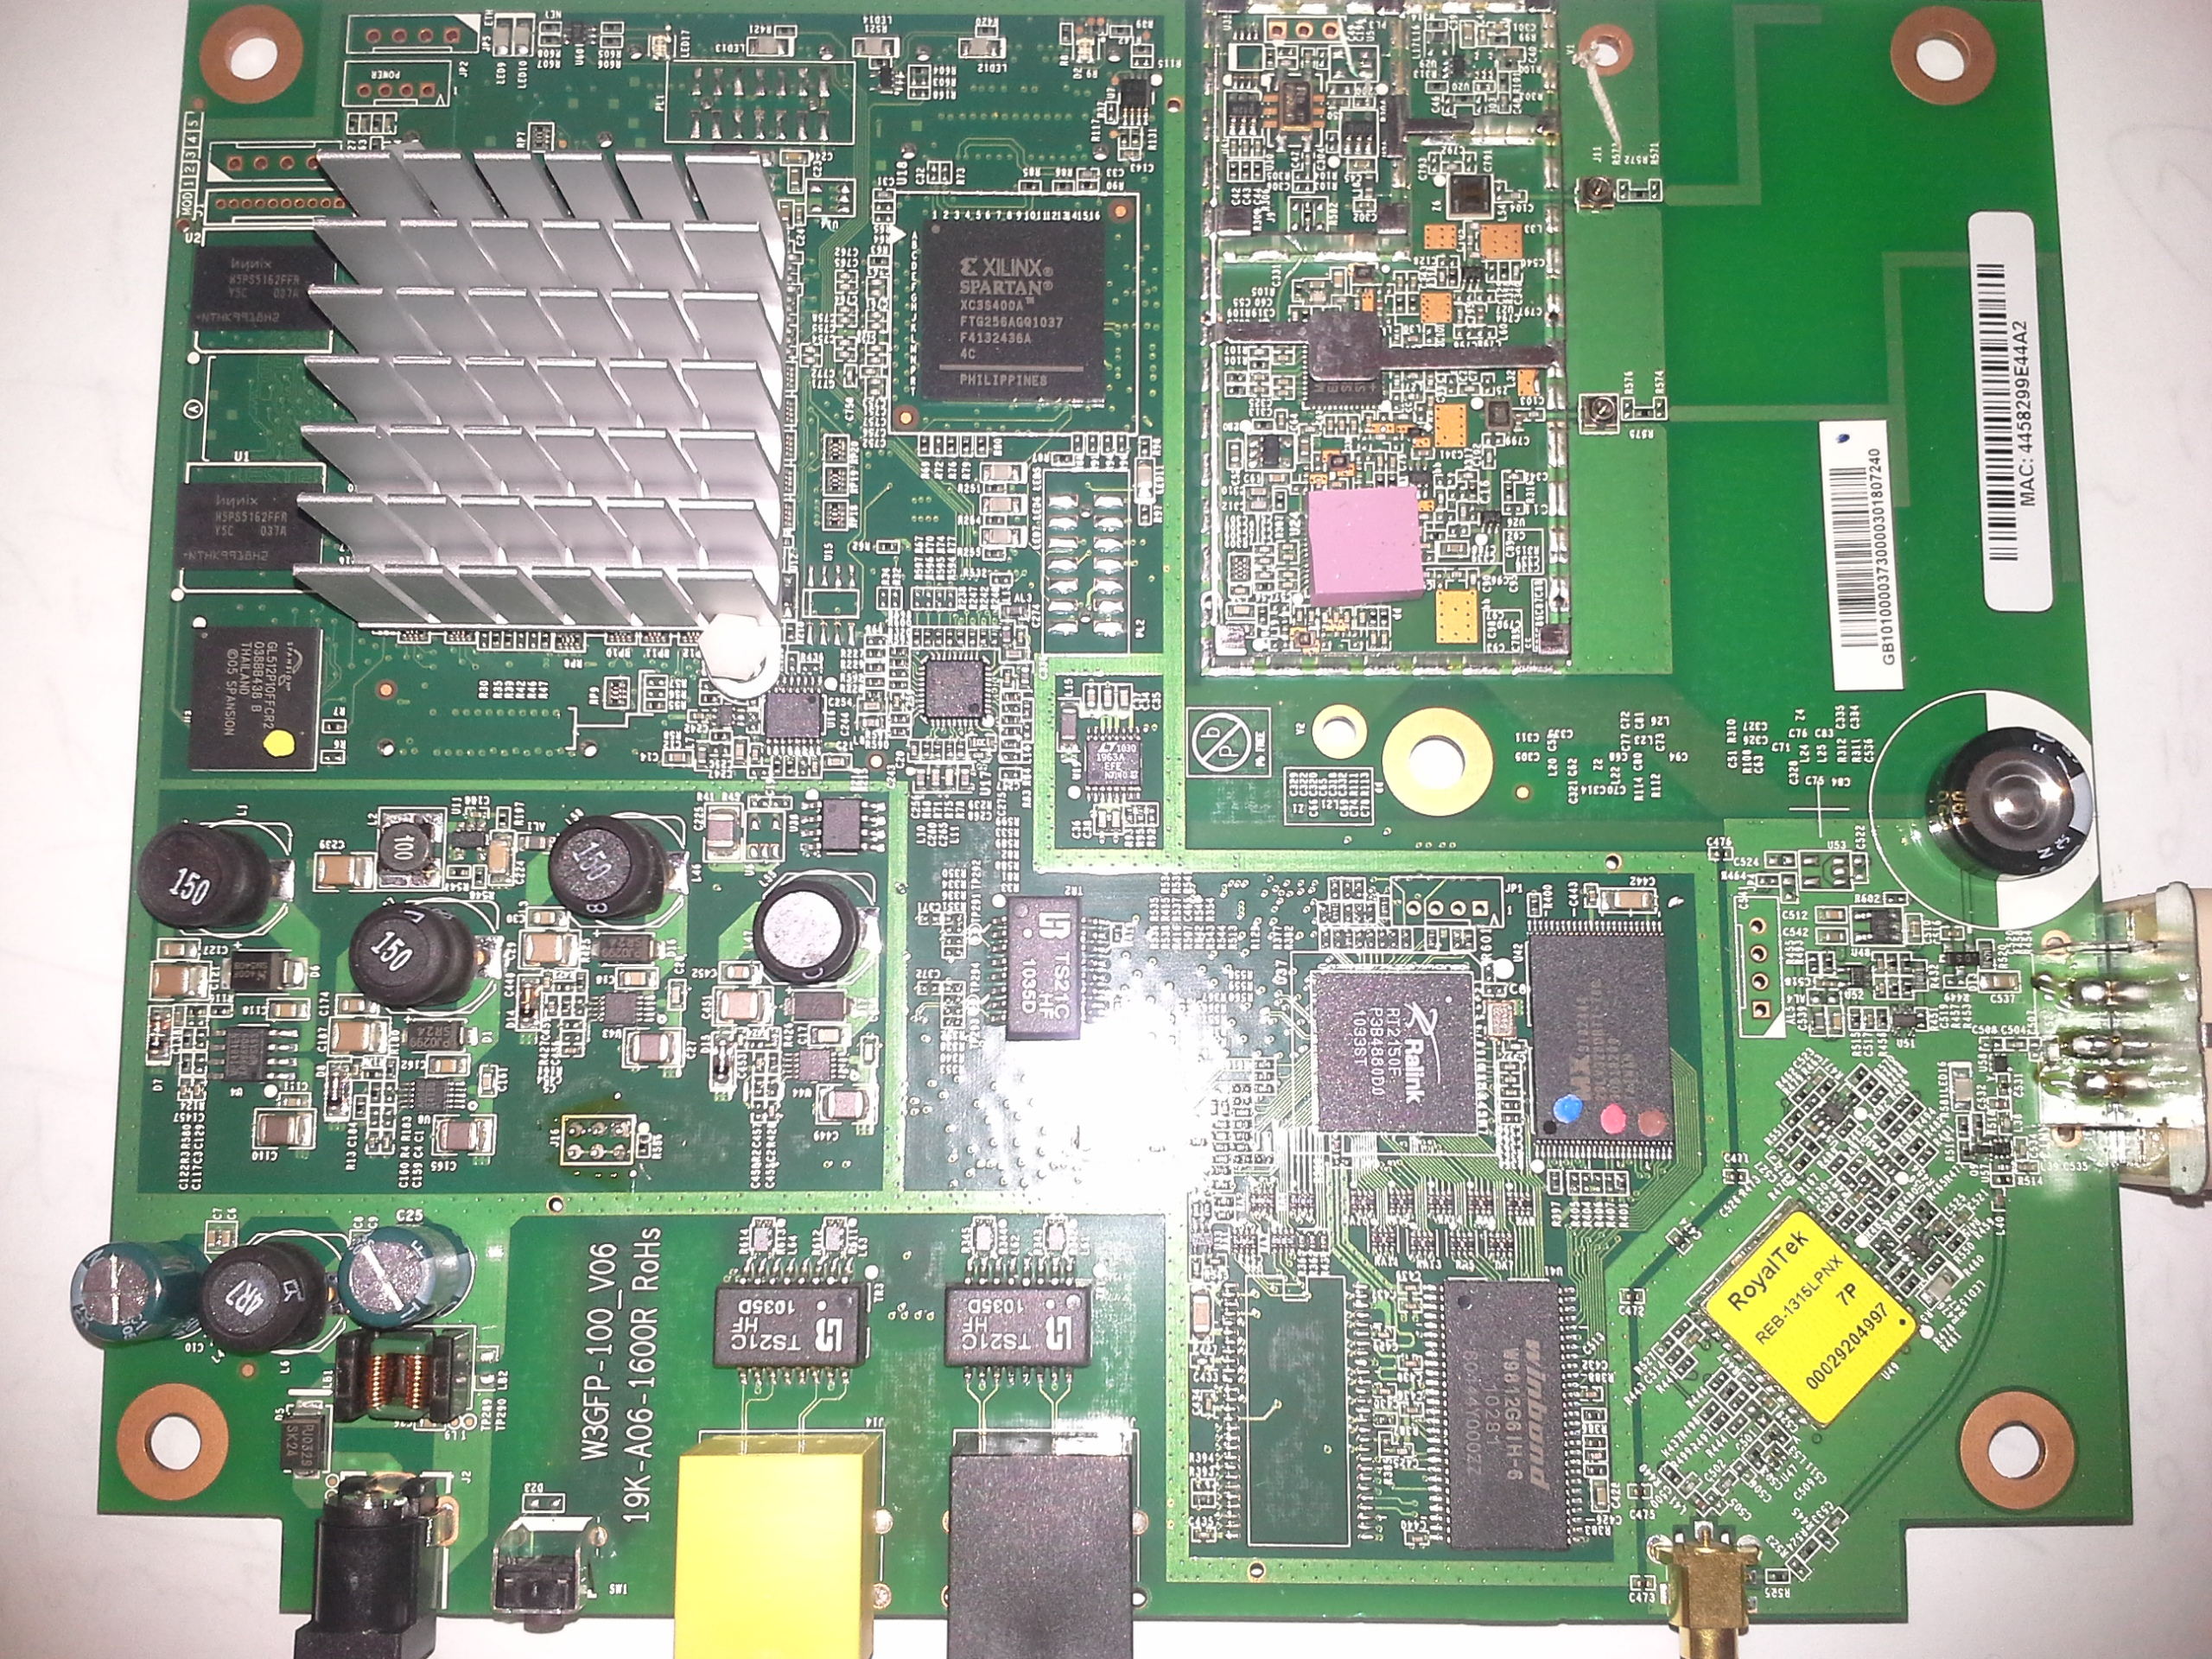

CPU: Arm 926EJ-S Processor  
Datasheet: https://support.**picochip**.com/**picochip**-resource.../**pc202**-10.../download



Clock frequency: 280 MHz  
Data cache size: 64KB   
Instruction cache size: 64 KB   
128KB Tightly Coupled Memory (TCM).

128KB on-chip SRAM.

Memory: Spansion GL512P Page Mode Flash  
DDR2: 200MHz   
RS232 pins (power, ground, tx, rx). No datasheet with pin information found (ASIC is confidential).

